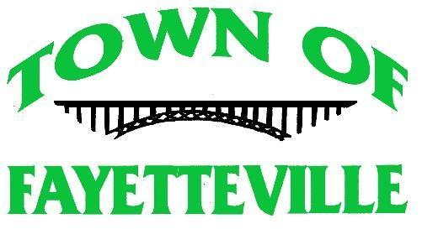

Town Hall - 125 North Court Street
September 20, 2022 - 4PM
Also Available Via
Zoom Meeting
https://zoom.us/j/3045740101
Prayer

Call to order

Pledge of Allegiance

Old Business
- Discuss and possibly Act on lease of historic grade school gym
Motion _________Seconded _________Action _________

New Business

- Discuss and Act on opening of bids for consideration of Limited Liability Insurance Agreement
Motion _________Seconded _________Action _________

Executive Session for Personnel Issue

Possible Executive Session for Legal Advice

Adjournment
Motion _________Seconded _________Action _________

