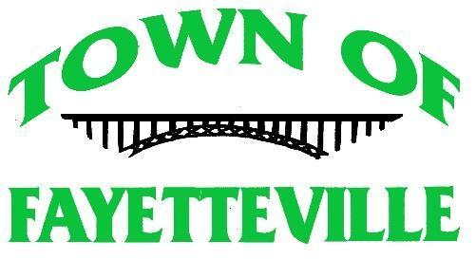
Special Council Meeting- Town Hall
125 North Court Street
12:00 p.m. ~ October 22, 2020
ZOOM MEETING
https://zoom.us/j/3045740101

If attending in person you must wear a mask when closer than 6ft. The occupancy for the room is limited to 50% (25 with masks/15 without)

Prayer

Call to order

Pledge of Allegiance

UNFINISHED BUSINESS:

- Discuss and Act on Halloween
Motion _________Seconded _________Action _________

NEW BUSINESS:

- Discuss and Act on approving Payroll Deduction for employees for Air Evac Insurance
Motion _________Seconded _________Action _______

- Discuss and Act on allowing Direct Deposit for employees
Motion _________Seconded _________Action _________

- Discuss and Act of Amendment 111.01 (b) to be compliant with the State Code for Special Meetings
Motion _________Seconded _________Action _________

Possible Executive Session for Personnel Issue

Possible Executive Session for Legal Advice

Adjournment
Motion _________Seconded _________Action _________

